Pipeline Design Demo – Simscape Fluids
Author: Oscar Molina – Copyright © MathWorks - 2025.

- Pipeline profile
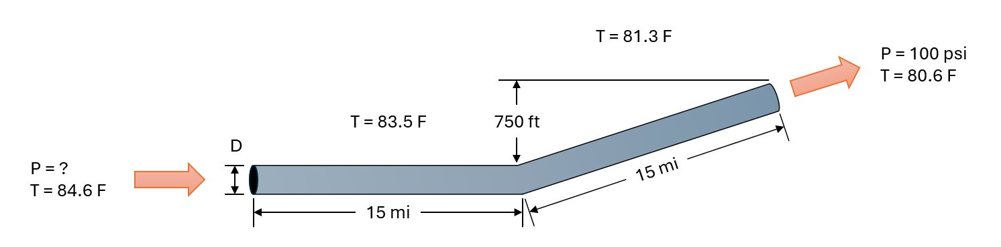
- Design considerations:
  - Fluid: Water
  - Required operating flowrate = 50,000 bbl/day
  - Maximum allowable operating pressure = 1550 psi
  - Pipeline outlet pressure = 100 psi
  - Variable frequency drive (VFD)
- System curves
  - Flowrate (barrel/day) vs Pump pressure (psi) generated with MATLAB/Simscape

  - Notice that hydrostatic pressure was calculated by the software
  - From the chart above, OD = 10” is the most convenient
  - Interpolation function: p = @(q) interp1(rate, pres(:,2), q)
  - Pump operating point = 1215 gpm @ 1049 psi (1 bpd = 0.024287 gpm)
  - Assume booster pump supplies fluid to main pump @ 100 psi
- Pump sizing
  - Pump suction pressure = 100 psi
  - Assume 70% pump efficiency
  - HP = (1215 * 1049) / (1714 * 0.7) = 1063 hp
- Pump specification: Flowserve Affinity Tool
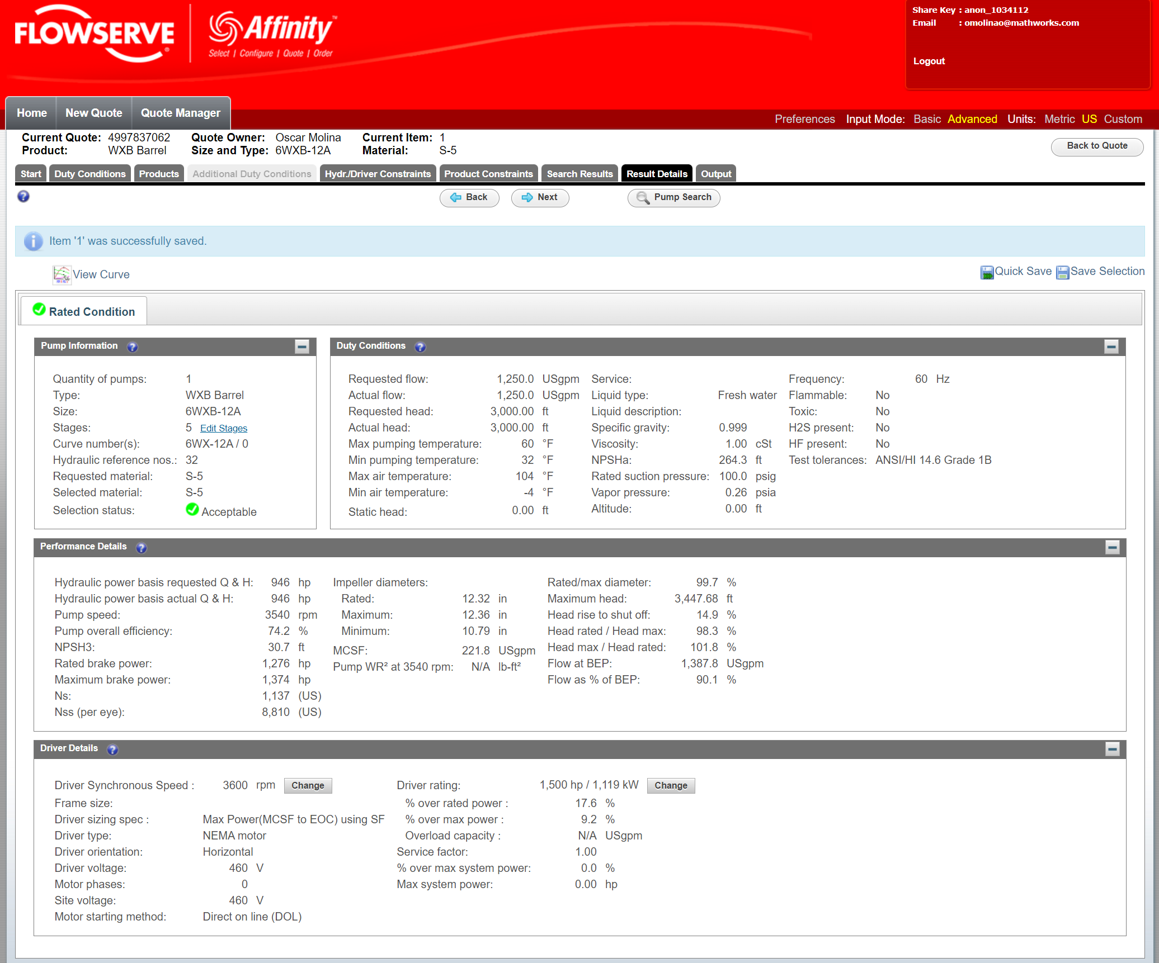
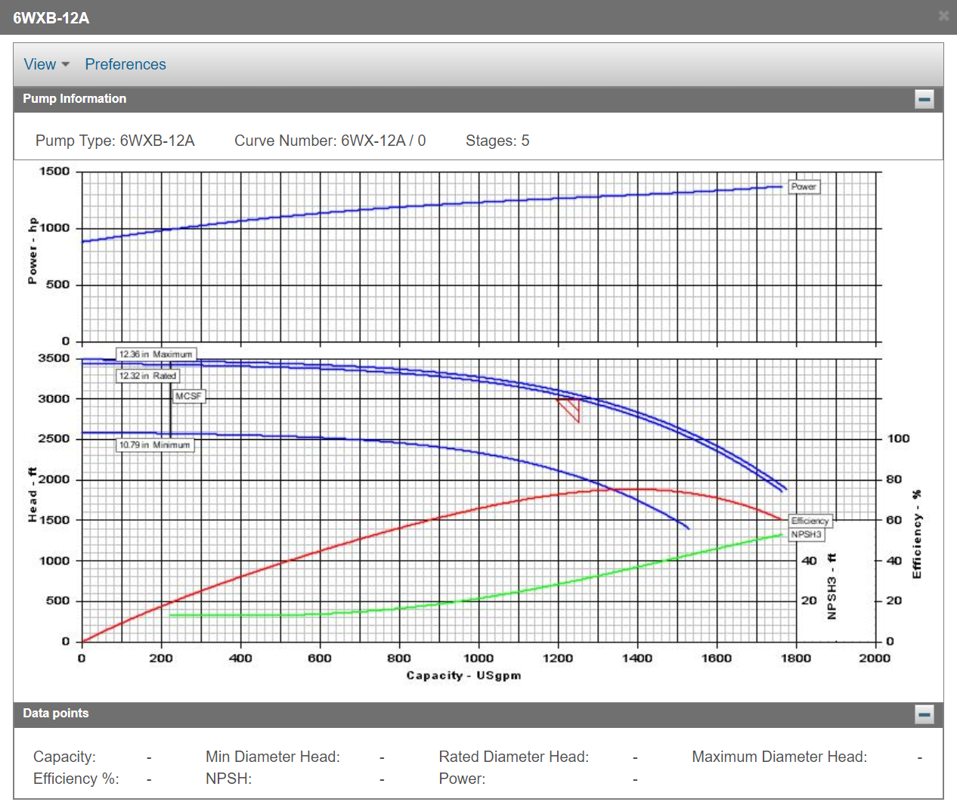
- Simscape Fluids model

